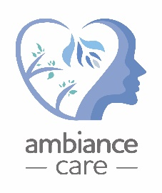

Equal opportunities monitoring form

The information supplied on this form will be used in total confidence and in accordance with current data protection legislation. It will help to ensure that the service properly monitors and conforms with its policies relating to the equality of opportunities.
Ambiance Care is an equal opportunities employer and seeks to ensure that all applicants are judged on merit regardless of race, colour, nationality, ethnic or national origin, age, sex, marital status, child or domestic care arrangements, sexual orientation or disability. The information will be treated as confidential and will not be used in selection, but for monitoring purposes only

Please indicate which ethnic group you consider yourself to belong?
Ethnic origin is not about nationality, place of birth or citizenship. It is about the group to which you perceive you belong. (Please tick the appropriate box)
White African Caribbean
European Chinese
Asian English
Africa Indian
Hispanic Mixed
Pakistani
Other (please specify): ………………………………………………………………………………………………

Please indicate which religion you consider yourself to belong to?
Buddhist Christian Hindu Jewish
Muslim Sikh No religion Prefer not to say
Other religion pleases state:

Are you: Male Female Prefer not to say
If you are undergoing the process of gender reassignment, please tick the box that applies to your future gender.
Do you live and work in a gender other than that assigned at birth:
Yes No Prefer not to say

How would you describe your sexuality?
Heterosexual Gay Lesbian Bi-sexual Prefer not to say

Are you pregnant or have had a baby in the last 6 months?
Yes No Prefer not to say N/A
Please indicate your age in the ranges below: (Please circle relevant range)
16-21 22-25 26-30 31-35 36-40 41-50 51-60 61-65
Prefer not to say

How would you describe your marital status?
Single Married/ Civil Partnership Divorced Co-habiting Widowed Prefer not to say

Do you consider yourself to have a disability? YES NO
A disabled person is defined under the Equality Act 2010 as someone with a ‘physical or mental impairment which has a substantial and long term adverse effect on that person’s ability to carry out normal day-to-day activities.’
If YES, please indicate the nature of the disability below:

